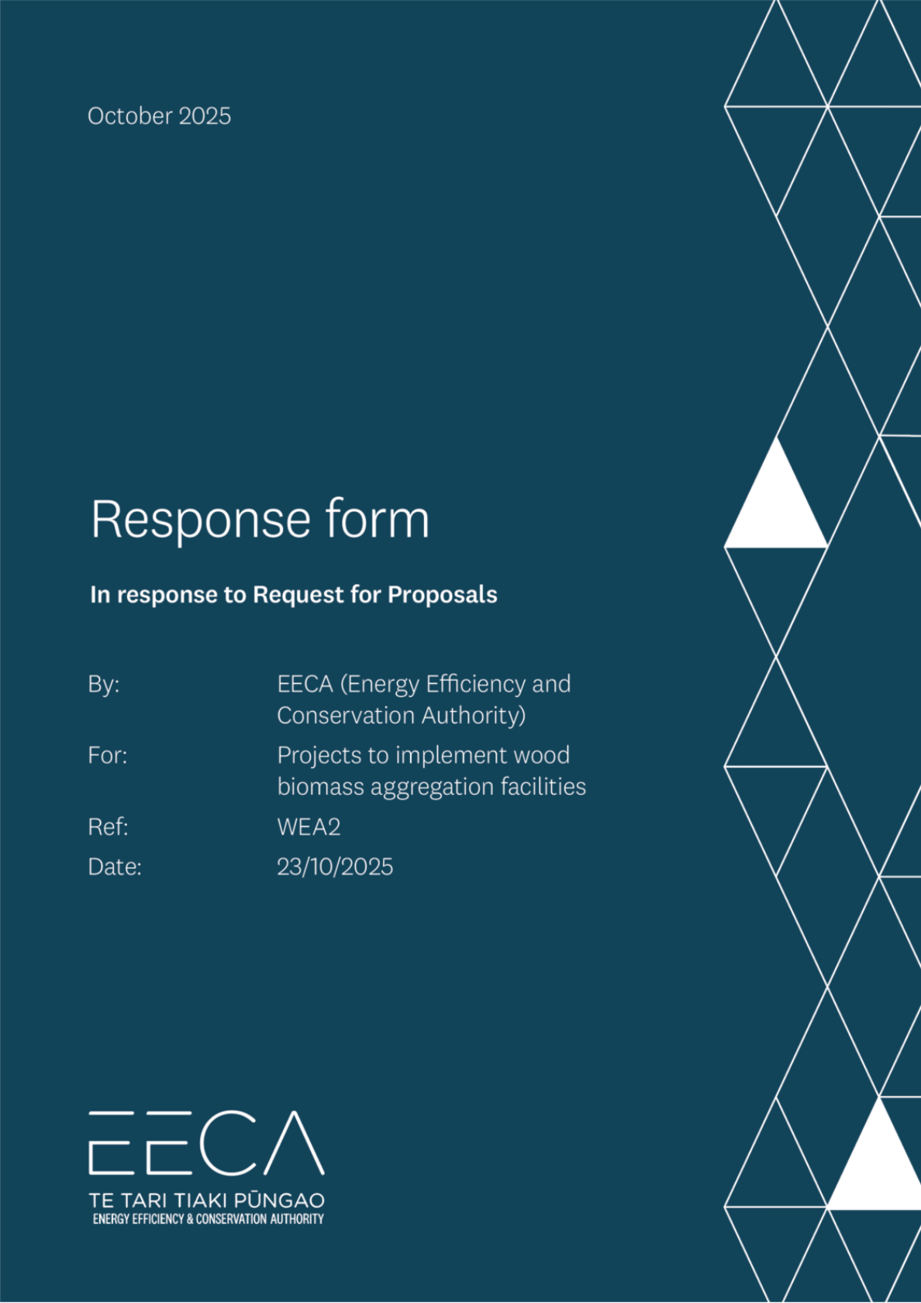

Request for Proposal (RFP) Response Form

Instructions for the Buyer
An RFP is often used when you require more detailed information from the Respondent. This is the Response Form that goes with the RFP.
Everything highlighted in RED in this document is information for the Buyer (that’s you). Delete these red parts prior to publishing the RFP. Anything shaded in YELLOW is customisable. When you have completed these areas please un-shade them.
Everything highlighted in PURPLE or BLUE is information for the Respondent.
Have you:
- Checked that the content in this Response Form is correct.
- Do not alter the section headings and sequence. Consistency makes it easier for Respondents.
- Checked, however, that the content is aligned to your agency's procurement practice.
- Deleted all Buyer instructions and tips (RED) and unshaded YELLOW bits.
- Checked the document is simple and easy to understand.

Instructions for Respondents
- Check that you have all the relevant documents, including:
- The Request for Proposals (RFP) which outlines the procurement.
- The Response Form (this one) to fill out your response.
- The RFP-Terms. Read these carefully.
- Before filling out this form, read the RFP carefully, particularly Section 2 (Our Requirements) and Section 3 (Our Evaluation Approach). This helps you quickly decide if you are the right fit for the requirements.
- Please follow the layout of this Response Form:
- Don’t change the section headings and sequence as this needs to be consistent across all Respondents.
- Insert any extra images or graphs either as part of your answer or in a separate attachment (but make it clear in the Response Form that you have done so).
- You can insert links to videos up to 50 MB in size.
- Everything highlighted in PURPLE in this document is information for the Respondent (you). Delete these PURPLE parts before sending the Response Form. Everything shaded in BLUE is customisable by you. When you have completed these areas please un-shade them.
The purple boxes are Supplier Tips. Delete these after reading.
Write your response in the blue sections. Un-shade the blue once you have filled these out.
- Remember to make a note of the Deadline for Questions. The Q & A section is really helpful for all Respondents so feel free to ask us anything if it is unclear.
RESPONDENT TIP: How to improve your RFP response

i
Head over to https://www.procurement.govt.nz/suppliers-2/ for some great resources to help you through the procurement process, including:
- Building up a collection of documents that you can use for all RFPs.
- Tips about responding to RFPs – what to include in your response and how to present it.
- An expanded check-list to work through.

Checklist for Respondents
Have you:
- Filled out all sections of the Response Form.
- Removed all the purple ‘Supplier Tip’ boxes from this Form.
- Deleted the PURPLE instructions from this Form.
- Un-shaded the BLUE highlighting where you fill out your answer.
- File size: Your email attachment should be no greater than 50MB (unless otherwise specified in Section 1.4 of the RFP).
- Arranged for the declaration to be signed. If this is a joint or consortium Proposal make sure all the consortium members sign separate declarations.
- Prepared your Proposal. We prefer that you submit your response through GETS. If you are unable to do that, send a digital copy by email to applications@eeca.govt.nz.
- Arranged for the Proposal to be submitted electronically before the Deadline for Proposals.

[insert your (Respondent’s) name and logo]

Request for Proposal (RFP) Response Form
In response to the Request for Proposals
By: EECA (Energy Efficiency & Conservation Authority)
For: Organisations seeking to commission projects for wood biomass aggregation facilities
Reference: WEA2

Date of this Proposal: [insert date of this document]

About the Respondent
RESPONDENT TIP

i
- This section gives the Buyer basic information about your organisation and identifies your Point of Contact for the RFP process.
- If an item is not applicable, e.g. you do not have a registered office, complete the box by stating 'not applicable'.
- If you are submitting a joint or consortium Proposal complete an 'Our profile' table for each member of the consortium. Cut and paste the table as appropriate. Provide only one Point of Contact for your joint/consortium Proposal.

Our profile
Choose one of these statements to complete, and delete the others [
This is a Proposal by [insert the name of your organisation] (the Respondent) to supply the Requirements.]
OR [This is a [joint/consortium] Proposal, by [insert the name of your organisation] and [insert the name of the other organisation/s] (together the Respondents) to supply the Requirements.]
Item | Detail
Full legal name: | [insert the name that you do business under]
Trading name (if different): | [if applicable]
Physical address: | [put the address of your head office]
Postal address: | [e.g. P.O Box address]
Registered office: | [if you have a registered office insert the address here]
Business website: | [url address]
Type of entity (legal status): | [sole trader / partnership / limited liability company / registered charity / other please specify]
NZBN number: | [if your organisation has a NZBN registration number insert it here]
Country of residence: | [insert country where you (if you are a sole trader) or your organisation is resident for tax purposes]
GST registration number: | [NZ GST number / if overseas please state]

Our Point of Contact
Item | Detail
Contact person: | [name of the person representing the Respondent and responsible for communicating with the Buyer]
Position: | [job title or position]
Phone number: | [landline]
Mobile number: | [mobile]
Email address: | [work email]

Response to the Requirements
RESPONDENT TIP

i
- Carefully read RFP Section 2 (Our Requirements) and Section 3 (Our Evaluation Approach). Then provide your response by demonstrating your organisation's ability to meet the criteria.
- Please mark any information that is 'commercially sensitive' or 'Confidential Information' to your business so that the Buyer knows. You cannot make the whole document confidential unless this is truly the case. Refer to the RFP-Terms for more information.
- Keep it simple. If an answer is in another document e.g. a marketing brochure, just cut and paste the relevant part into this form. Do not show the whole document unless necessary - the Buyer may not read it all.
- Any video or separate document should be uploaded and the link inserted into this form.
- You may include extra information in your Proposal but only if it adds value and is relevant.

Pre-conditions

RESPONDENT TIP

i
- You must be able to answer 'yes' to each of these pre-conditions. Make sure you can verify this.
- 'Yes' means you currently meet the pre-condition. If you cannot answer 'yes' to all, your Proposal will not be evaluated further.

Note that evidence for these pre-conditions will need to be provided as part of the detailed responses in Section 3.

# | Pre-condition | Meets
 | Be a New Zealand registered business and deliver the project in New Zealand | [Yes/No]
 | The Project is to establish a wood biomass aggregation facility primarily for the end purpose of supporting wood energy demand | [Yes/No]
 | The facility must be available for multiple parties to deposit wood biomass | [Yes/No]
 | The facility is for woody biomass derived from commercial plantation forestry of pinus radiata, douglas fir, and/or eucalyptus | [Yes/No]
 | The facility is a minimum size of at least one hectare and 5,000 tonnes storage potential | [Yes/No]
 | Projects are investment ready with cost components detailed to an accuracy level of ±30% or better, with planned commissioning dates before 30 June 2027 | [Yes/No]
 | The Applicant has not received or will not receive any other New Zealand Government Funding in connection with this Project | [Yes/No]

Overview of your project
Please provide an overview of your project. Describe the project development to date, key organisations involved in developing the project, equipment suppliers, and financial partners. Explain the funding request of this proposal and the process and timeline to commissioning the project.
RESPONDENT TIP

i
- This should summarise your entire response in a paragraph or two. Keep it simple.
- Your competitors may all have similar skills, tools and methods. Know what sets you apart, and clearly communicate it in your response.

Write your overview here

Detailed Responses
RESPONDENT TIP

i
- These are questions relating to the evaluation criteria (see Section 3 of the RFP). Your Proposal will be scored against your answers to these criteria. Aim to give answers that are relevant, concise and comprehensive.
- Consider the % weighting for each criterion. The higher the weighting the more important it is. Take the weightings into account in deciding how much detail to include.
- If you have made any assumption about the Requirements or delivery, clearly state the assumption.
- There may be several questions that relate to one criterion. If these questions are not individually weighted assume that they are of equal importance.

Please provide answers to the questions in the space provided, or indicate whether the answer to the question is included in another attachment to your response.

Project Details
- Applicant’s business and core operations. Or if this is a new entity being created for the purposes of the facility, detail the shareholders.
[insert answer here]
- Site location of facility, and whether this has already been secured. Detail the strategic benefits of this location.
[insert answer here]
- Size of facility in hectares.
[insert answer here]
- Size of the facility in maximum potential storage at any given time in green metric tonnes.
[insert answer here]
- Estimated average volume of wood biomass stored at the facility in green metric tonnes.
[insert answer here]
- Estimated annual average input of wood biomass, once fully operational, into the facility in green metric tonnes per annum.
[insert answer here]
- Estimated annual average output of final product(s), once fully operational, out of the facility in tonnes per annum and GJ per annum per product (e.g. seasoned logs, wood chip, hog fuel). Provide details on the expected average annual output for energy and non-energy products.
[insert answer here]
- Outline the operations of the proposed woody biomass aggregation facility. Including what regions of forestry are intended to be serviced, what format(s) of material will be accepted into the facility (e.g. industrial logs, binwood, chip, etc), how long is wood biomass intended to be stored for on average, what processing, if any, will be done on site (e.g. chipping, hogging, drying), how will material be managed in the facility to ensure low levels of contamination and high quality of products (e.g. bark and fines management, ground coverage, weather proofing), how will material enter and exit the facility, how material will be weighed and stock levels managed, how product’s moisture content will be measured and managed (if applicable).
[insert answer here]
- Outline the commercial arrangements of the facility. Including who will own the facility, who will operate the facility, detail how multiple parties are enabled to deposit eligible wood biomass into the facility (e.g. payment basis, who are the known entities, and the process for new entities), how costs and revenues will be allocated.
[insert answer here]
- Outline the inputs to the facility. What type of material (e.g. cutover or landing residues, binwood, industrial grade logs, other residues), from what catchment area from which sources and forest owners. Outline the counterfactual for this material without the facility, or the current outlet for this material.
[insert answer here]
- Outline the outlet(s) / demand(s) / offtake(s) for the material (e.g. wood energy end user or wood energy manufacturing facility). Detail whether these demand(s) already exist or are in development. Detail the dependency on this wood biomass aggregation facility either in commissioning or scaling based on the demand project(s) commissioning and provide information to demonstrate the likelihood of the demand project(s) commissioning. Detail the value of the facility by outlining its impact on the cost, security, and quality of the products.
[insert answer here]
- Detail the total cost of establishing the facility and the associated accuracy.
[insert answer here]
- Detail the total eligible costs (see section 2.1 of the RFP document) of establishing the facility, and provide evidence of the cost (e.g. attaching quotations).
[insert answer here]
- Detail the total funding ask from EECA for this project - the absolute cap is 30% towards eligible costs and maximum of $1M per project. Note the total budget for this procurement is $3M, and EECA expects that this request for proposal will be oversubscribed and government value for money is a weighted evaluation criteria.
[insert answer here]
- Describe why this funding is necessary for the project to proceed. Describe the impact of funding on the project in timeline, scale, and other considerations. Detail the counterfactual case for if funding was not received.
[insert answer here]
- Detail the timeline from now for project commissioning date.
[insert answer here]
- Detail the contractors and processes involved in commissioning the project.
[insert answer here]
- Detail that the facility consenting is arranged for the facility, or the process and timeline for getting consent.
[insert answer here]
- Provide evidence that the organisation can effectively deliver the project, such as examples of other projects from the organisation.
[insert answer here]
- Detail risks and mitigations for the project.
[insert answer here]
- Outline any other benefits of the project.
[insert answer here]
- Detail that appropriate systems and processes will be in place to ensure the health and safety of the site operation.
[insert answer here]
- Provide the financial business case for the project. This includes a high-level breakdown of operating costs associated with the project (e.g. fuel, labour, maintenance), project revenues, project financial metrics such as NPV, payback period, and internal rate of return (IRR). Detail the key assumptions made for financial analysis (e.g. fibre price, discount rate, product prices). This can be attached as separate documents.
[insert answer here]
- Any other details relevant to this project.
[insert answer here]

Proposed Contract
RESPONDENT TIP

i
- The terms and conditions of the Proposed Contract are in Section 4 of the RFP. The Buyer needs to know whether or not you are prepared to do business based on the Proposed Contract.
- If you have any suggestions or changes that you wish to alter in the Proposed Contract, please note below (and you may be asked why it is important).
- In deciding which Respondents to shortlist the Buyer will take into account each Respondent's willingness to meet the Contract terms and conditions.

Choose one and delete the other:
Having read and understood the Proposed Agreement, in the RFP Section 4, I confirm that these terms and conditions are acceptable. If successful, I agree to sign a Contract based on the Proposed Contract, or such amended terms and conditions of Contract as are agreed with the Buyer following negotiations.
OR
Having read and understood the Proposed Agreement, in the RFP Section 4, I have the following suggestions to make. If successful, I agree to sign a Contract based on the Proposed Contract subject to negotiating the following clauses:
Clause | Concern | Proposed solution
[insert number] | [briefly describe your concern about this clause] | [describe your suggested alternative wording for the clause or your solution]
[insert number] | [briefly describe your concern about this clause] | [describe your suggested alternative wording for the clause or your solution]

Referees
RESPONDENT TIP

i
- Here you are asked to provide the names and contact details of referees. These must be work related referees, preferably not a friend or family member (Referees can be a family member if they can provide a truly independent reference based on the work).
- If you have provided case studies as evidence of Track Record please include details of referees from those examples here.
- The best referees are those who you have recently delivered similar goods or services for.
- Before including their details check with them to make sure that they consent to acting as referee on behalf of your organisation.
- Please note: In providing these referees you authorise us to collect from the referees any information about your organisation that we consider relevant to the RFP, except commercially sensitive information about pricing or contract terms, and use such information in the evaluation of your Proposal. All information provided by the referee will be treated as confidential to both you and us, i.e. we are not required to disclose that information to you, but our use and disclosure of that information is subject to our confidentiality obligations under the RFP-Terms.
Please supply the details of three referees for your organisation. Include a brief description of the goods or services that your organisation provided, and when - from the beginning date to the end date.
First referee
Name of referee: | [insert name of the referee]
Name of organisation: | [insert name of their organisation]
Goods/services provided: | [brief description of the goods/services you provided to this referee]
Date of provision: | [insert the date when you provided the goods/services]
Address: | [insert street address]
Phone: | [insert mobile or landline]
Email: | [insert email address]
Relationship | [describe your relationship with this referee – e.g. Contract Manager/ Contract Owner, Key Contact]

Second referee
Name of referee: | [insert name of the referee]
Name of organisation: | [insert name of their organisation]
Goods/services provided: | [brief description of the goods/services you provided to this referee]
Date of provision: | [insert the date when you provided the goods/services]
Address: | [insert street address]
Phone: | [insert mobile or landline]
Email: | [insert email address]
Relationship | [describe your relationship with this referee – e.g. Contract Manager/ Contract Owner, Key Contact]

Third referee
Name of referee: | [insert name of the referee]
Name of organisation: | [insert name of their organisation]
Goods/services provided: | [brief description of the goods/services you provided to this referee]
Date of provision: | [insert the date when you provided the goods/services]
Address: | [insert street address]
Phone: | [insert mobile or landline]
Email: | [insert email address]
Relationship | [describe your relationship with this referee – e.g. Contract Manager/ Contract Owner, Key Contact]

Please contact me before you approach a referee for a reference | [Yes/Not required]

Our declaration
RESPONDENT TIP

i
- Here you are asked to make a formal declaration. Select 'agree' or 'disagree' at the end of each row. If you don't, you will be deemed to have agreed.
- Have the declaration signed by someone who is authorised to sign and able to verify the declaration, e.g. chief executive or a senior manager.
- If you are submitting a joint or consortium Proposal each party involved in the joint or consortium Proposal must complete a separate declaration.

Respondent’s declaration
Topic | Declaration | Respondent’s declaration
RFP-Terms: | I/we have read and fully understand this RFP, including the RFP-Terms, as amended by Section 1.5 of the RFP (if applicable). I/we confirm that the Respondent agrees to be bound by them. | [agree / disagree]
Collection of further information: | The Respondent authorises the Buyer to:  - collect any information about the Respondent, except commercially sensitive pricing information, from any relevant third party, including a referee, or previous or existing client  - use such information in the evaluation of this Proposal. The Respondent agrees that all such information will be confidential to the Buyer. | [agree / disagree]
Requirements: | I/we have read and fully understand the nature and extent of the Buyer’s Requirements as described in Section 2. I/we confirm that the Respondent has the necessary capacity and capability to fully meet or exceed the Requirements and will be available to deliver throughout the relevant Contract period. | [agree / disagree]
Ethics: | By submitting this Proposal the Respondent warrants that it:  - has not entered into any improper, illegal, collusive or anti-competitive arrangements with any Competitor  - has not directly or indirectly approached any representative of the Buyer (other than the Point of Contact) to lobby or solicit information in relation to the RFP  - has not attempted to influence, or provide any form of personal inducement, reward or benefit to any representative of the Buyer. | [agree / disagree]
Offer Validity Period: | I/we confirm that this Proposal, including the price, remains open for acceptance for the Offer Validity Period stated in Section 1, paragraph 1.5 of the RFP. | [agree / disagree]
Conflict of Interest declaration: | The Respondent warrants that it has no actual, potential or perceived Conflict of Interest in submitting this Proposal, or entering into a Contract to deliver the Requirements.  Where a Conflict of Interest arises during the RFP process the Respondent will report it immediately to the Buyer’s Point of Contact. | [agree / disagree]
Details of conflict of interest: | [if you think you may have a conflict of interest briefly describe the conflict and how you propose to manage it or write ‘not applicable’].

DECLARATION BY THE RESPONDENT
I/we declare that in submitting the Proposal and this declaration:
- the information provided is true, accurate and complete and not misleading in any material respect
- the Proposal does not contain any material that will infringe a third party’s intellectual property rights
- I/we have secured all appropriate authorisations to submit this Proposal, to make the statements and to provide the information in the Proposal and I/we am/are not aware of any impediments to enter into a Contract to deliver the Requirements.
I/we understand that the falsification of information, supplying misleading information or the suppression of material information in this declaration and the Proposal may result in the Proposal being eliminated from further participation in the RFP process and may be grounds for termination of any Contract awarded as a result of the RFP.
By signing this declaration the signatory below represents, warrants and agrees that they have been authorised by the Respondent to make this declaration on its/their behalf.

Signature:
Full name:
Title/position:
Name of organisation:
Date:

