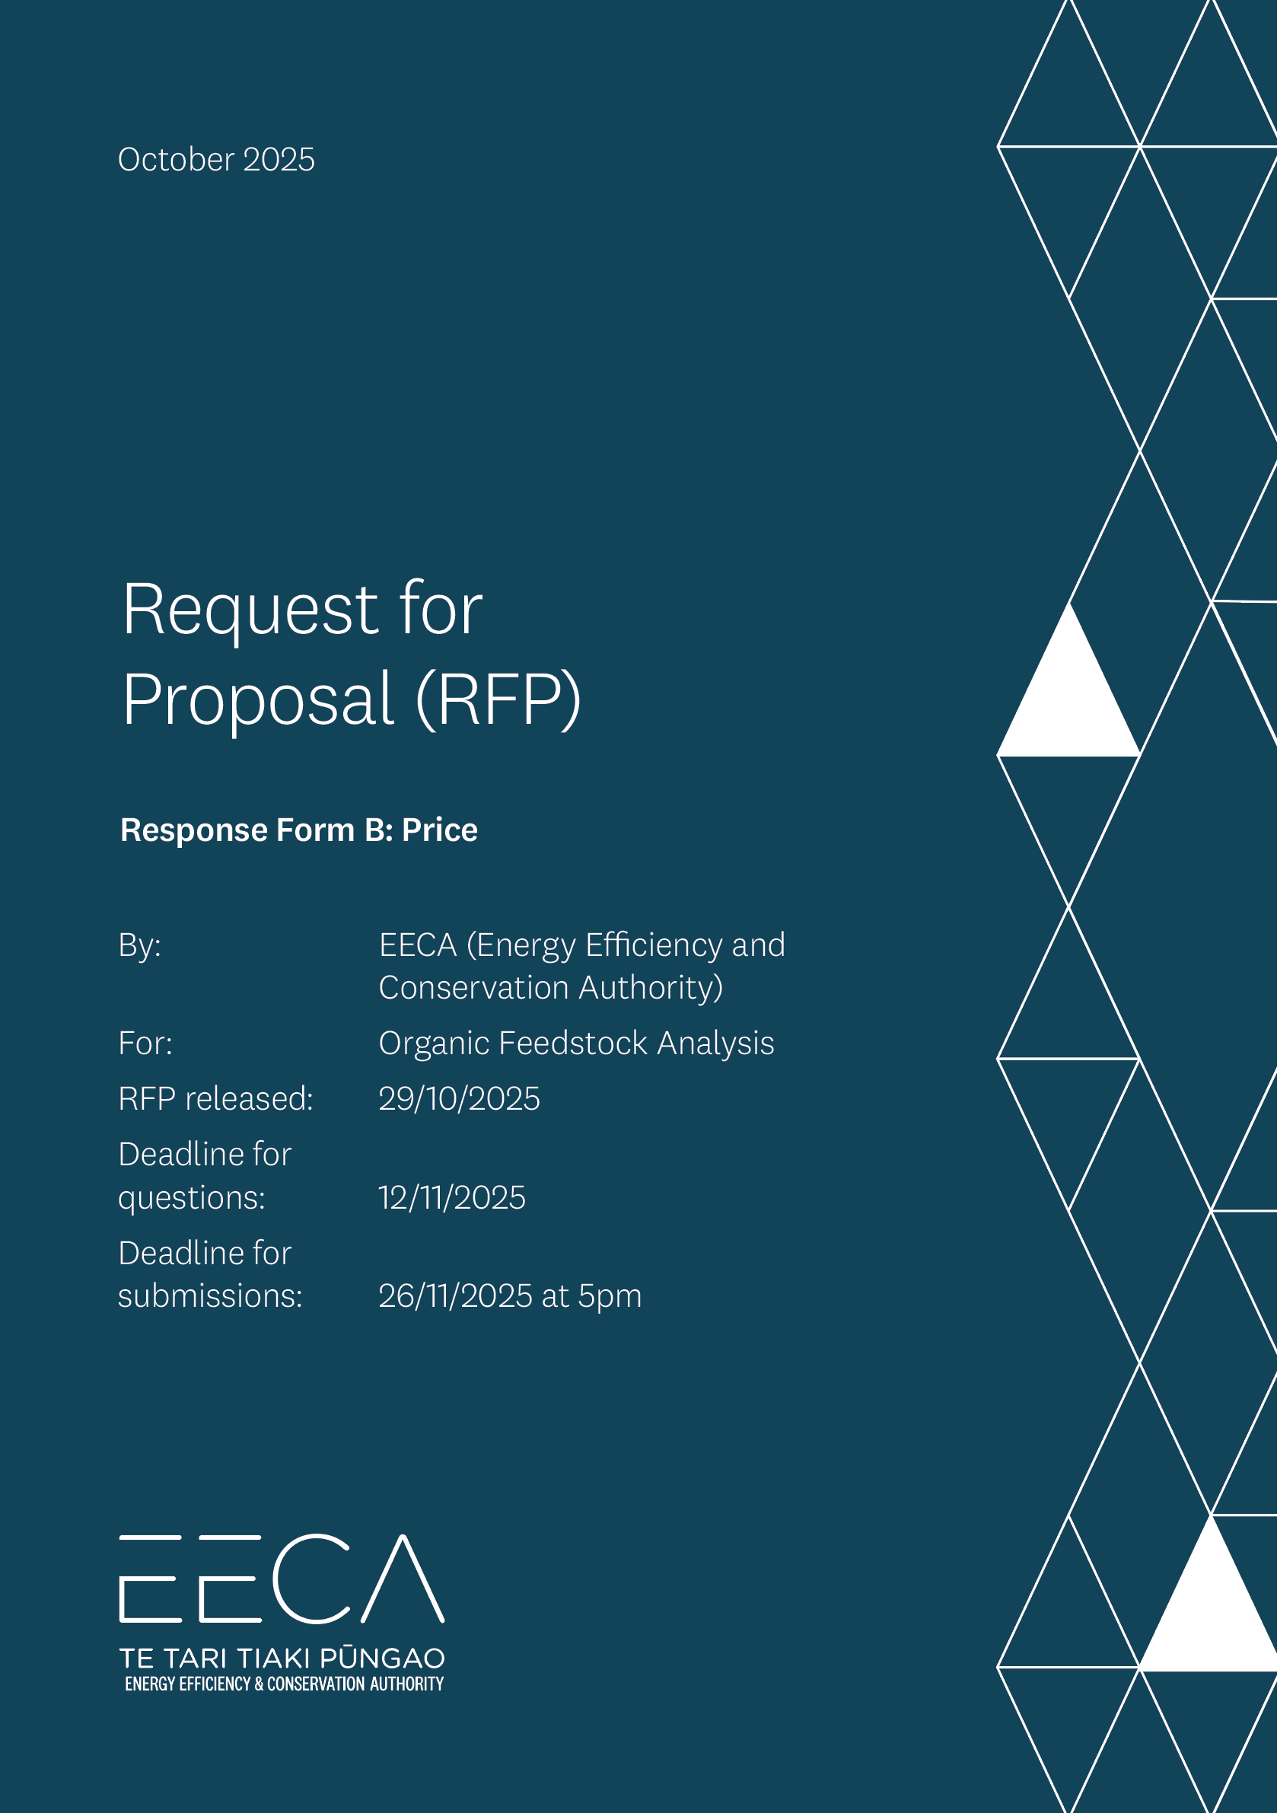

Instructions for Respondents

- Check that you have all the relevant documents, including:
  - The Response Form A to fill out your non-price response.
  - The Response Form B (this one) to fill out your price response
- Before filling out this form, read the Request for Proposal (RFP) carefully.

- Please follow the layout of this Response Form.
  - Don’t change the section headings and sequence as this needs to be consistent across all Respondents.
- Everything in PURPLE is information for the Respondent (you). Delete these PURPLE parts before submitting your Response.

- Write your response in the BLUE highlighted sections. Un-shade the BLUE once you have filled these out.

Checklist for Respondents

Have you:
- Filled out all sections of the Response Forms A & B
Response Forms A & B are to be submitted separately
- Deleted the PURPLE instructions from this Form.
- Un-shade the BLUE highlighting where you fill out your answer.
- Signed the declaration.
- Submitted your Quote before the Deadline for Quotes.

Use your (Respondent’s) business letterhead

Request for Proposal (RFP)

Response Form B: Price

By: <insert Respondent Name>

For: Organic Feedstock Analysis

Date of this Proposal: <Insert Date>

[your business website]
[your business street address]
[City]

Request for Proposal: Organic Feedstock Analysis

Price as a weighted criterion
Public Value (Based on Whole of Life Cost) | Weighting 20%
Provide the total price and breakdown by individual region tendered for (NZD, Excluding GST)
Insert answer here
Detail any other cost or benefits
Insert answer here

Pricing Schedule
Submit your financial information and pricing using the following pricing schedule. Provide as detailed a breakdown of the services as possible, and describe any assumptions where relevant (i.e. the number of people being applied to a job and why, or if that changes over time). Where possible, please provide information regarding sub-contractor input as well as your input.
Please note, you can use as many rows as required.
Delete tables if not applicable to your bid.

Breakdown of the fixed price cost by region for delivering the requirements of the RFP:

Region 1: Hawkes Bay

Item | Description | Sub Total  (NZD Excl. GST)
[Insert Line item, add rows as required] | [Item Description] | [$X]
[Insert Line item, add rows as required] | [Item Description] | [$X]
[Insert Line item, add rows as required] | [Item Description] | [$X]
Total: |  | [$X]

Region 2: Taranaki

Item | Description | Sub Total  (NZD Excl. GST)
[Insert Line item, add rows as required] | [Item Description] | [$X]
[Insert Line item, add rows as required] | [Item Description] | [$X]
[Other e.g. temporary storage, administrative costs, disposal] | [Item Description] | [$X]
Total: |  | [$X]

Region 3: Auckland

Item | Description | Sub Total  (NZD Excl. GST)
[Insert Line item, add rows as required] | [Item Description] | [$X]
[Insert Line item, add rows as required] | [Item Description] | [$X]
[Other e.g. temporary storage, administrative costs, disposal] | [Item Description] | [$X]
Total: |  | [$X]

Assumptions
Assumptions
State any assumptions you have made in relation to the cost and pricing information
Insert Answer

I am authorised to submit this Quote on behalf of [insert name of your business]:

Signature: | [sign here]
Full name: | [insert your name – use capital letters]
Title/position: | [insert your job title or position]
Date: | [insert date when you signed this document]

