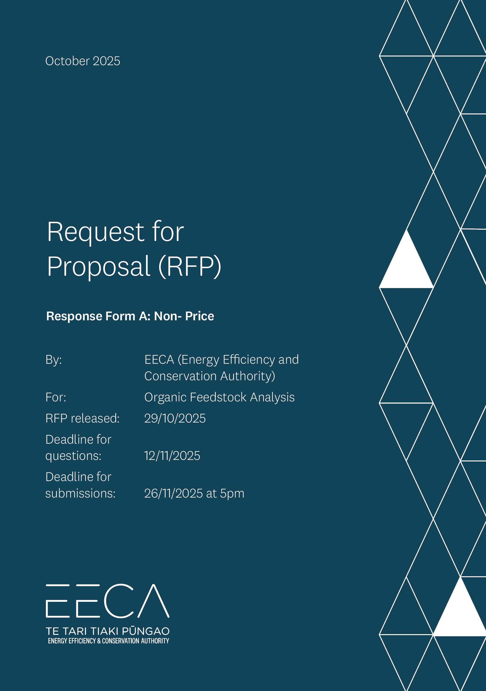

Request for Proposal (RFP) Response Form

Instructions for Respondents
- Check that you have all the relevant documents, including the:
- Request for Proposals (RFP), which outlines the procurement
- Response form (this one), to fill out your response
- RFP-Terms ―please read these carefully.
- Before filling out this form, read the RFP carefully, particularly Section 2 (Our requirements) and Section 3 (Our evaluation approach). This helps you quickly determine how you are a good fit for the requirements.
- Please follow the layout of this response form.
- Don’t change the section headings and sequence to ensure consistency across all respondents, you may use your own organisational template and branding.
- You may insert extra images or graphs within your response or as a separate attachment ― just make sure to note this in the response form.
- You can add links to videos (up to 50 MB in size).
- Avoid linking to lengthy documents where possible, as they may not be reviewed.
- Everything highlighted in PURPLE in this document is information for the respondent (you). Please delete these PURPLE parts before sending the response form. Everything shaded in BLUE is customisable by you. When you have completed these areas, please un-shade them.
The purple boxes are supplier tips. Please delete these after reading.
Write your response in the blue sections. Un-shade the blue once you have filled these out.
- Remember to note the deadline for submitting questions. The Q&A section is there to support all respondents, so feel free to ask us if anything is unclear.
RESPONDENT TIP: How to improve your RFP response

i
Head over to https://www.procurement.govt.nz/suppliers-2/ for some great resources to help you through the procurement process, including:
- building a collection of documents that you can use for all RFPs
- tips about responding to RFPs ― what to include in your response and how to present it
- an expanded checklist to work through.

Checklist for respondents
Have you:
- Filled out all sections of the response form.
- Removed all the purple ‘Respondent Tip’ boxes from this form.
- Deleted the PURPLE instructions from this form.
- Un-shaded the BLUE highlighting where you fill out your answer.
- File size: Your email attachment should be no larger than 50MB (unless otherwise specified in Section 1.4 of the RFP).
- Arranged for the declaration to be signed. If this is a joint or consortium proposal, make sure all the consortium members sign separate declarations.
- Prepared your proposal
Submit your response via the Government Electronic Tendering System
- Submitted your rate card as a separate document to your written response.
- Arranged for the proposal to be submitted before the deadline for proposals.

[insert your (Respondent’s) name and logo]

Request for Proposal (RFP)

Response Form A: Non- Price

By: <insert Respondent Name>

For: Organic Feedstock Analysis

Date of this Proposal: <Insert Date>

About the Respondent
RESPONDENT TIP

i
- This section gives the Buyer basic information about your organisation and identifies your point of contact for the RFP process.
- If an item is not applicable, e.g. you do not have a registered office, complete the box by stating 'not applicable'.
- If you are submitting a joint or consortium proposal complete an 'Our profile' table for each member of the consortium. Cut and paste the table as needed. Provide only one point of contact for your joint/consortium proposal.

Our profile
Choose one of these statements to complete, and delete the others [
This is a proposal by [insert the name of your organisation] (the respondent) to supply the requirements.
Item | Detail
Full legal name: | [insert the name that you do business under]
Trading name (if different): | [if applicable]
Physical address: | [put the address of your head office]
Postal address: | [e.g. P.O Box address]
Registered office: | [if you have a registered office insert the address here]
Business website: | [url address]
Type of entity (legal status): | [sole trader / partnership / limited liability company / registered charity / other please specify]
NZBN number: | [if your organisation has a NZBN registration number insert it here]
Country of residence: | [insert country where you (if you are a sole trader) or your organisation is resident for tax purposes]
GST registration number: | [NZ GST number / if overseas please state]

Our point of contact
Item | Detail
Contact person: | [name of the person representing the respondent and responsible for communicating with the buyer]
Position: | [job title or position]
Phone number: | [landline]
Mobile number: | [mobile]
Email address: | [work email]

Response to the requirements
RESPONDENT TIP

i
- Carefully read RFP Section 2 (Our requirements) and Section 3 (Our evaluation approach). Then provide your response by demonstrating your organisation's ability to meet the criteria.
- Please mark any information that is 'commercially sensitive' or 'confidential information' to your business so that the buyer knows. You cannot make the whole document confidential unless this is truly the case. Refer to the RFP-Terms for more information.
- Keep it simple. If an answer is in another document e.g. a marketing brochure, just cut and paste the relevant part into this form. Do not show the whole document unless necessary ― the buyer may not read it all.
- Any video or separate document should be uploaded and the link inserted into this form.
- You may include extra information in your proposal but only if it adds value and is relevant.

Scope of Submission
Please select the regions below that this response to the request for proposal is concerned with:
Region | Definition | Bid Submitted
- Hawkes Bay | All of Wairoa, Hastings and Central Hawkes Bay Districts | Select one <yes/no>
- Taranaki | All of New Plymouth, South Taranaki and Stratford Districts | Select one <yes/no>
- Auckland | All of Rodney, Albany, Waitemata and Gulf, North Shore, Waitakere, Whau, Albert-Eden-Roskill, Orakei, Maungakiekie-Tamaki, Howick, Manukau, Manurewa-Papakura and Franklin Wards | Select one <yes/no>

Overview of your solution
Please provide an overview of your solution. Describe the technical aspects and elements of your service offering.
RESPONDENT TIP

i
- This should summarise your entire response in a paragraph or two. Keep it simple.
- Your competitors may all have similar skills, tools and methods. Know what sets you apart and clearly communicate it in your response.

Write your overview here

Evaluation Criteria and Price

Detailed response to Requirements
RESPONDENT TIP

i
- These are questions relating to the evaluation criteria (see Section 3 of the RFP). Your proposal will be scored against your answers to these criteria. Aim to give answers that are relevant, concise, and comprehensive.
- Consider the percentage weighting for each criterion. The higher the weighting the more important it is. Take the weightings into account when deciding how much detail to include.
- If you have made any assumption about the requirements or delivery, clearly state the assumption.
- There may be several questions that relate to one criterion. If these questions are not individually weighted assume that they are of equal importance.

Response to non-price criteria

Criteria | Weighting
- Proposed Solution
- How well your proposed solution and how it covers all aspects required within the project scope of work.  - Identification of the main risks, uncertainties and any limitations associated  with your solution that may affect successful delivery.  - Description of the methods used to identify risks, perceived impacts and mitigations.  - Suitability of how the deliverables of the engagement will be prepared and presented. | 35%
<Insert Response Here>
- Capacity
- The comprehensiveness of previous or current examples of similar services delivered to clients (e.g., quantity, quality, delivered on time, to specification, and within budget) demonstrating your organisational ability to meet the requirements.  Include:  - the contract/name of client (including contact details for reference purposes), location of contract, and dates you provided the goods/services,  - a brief description of the scope of services performed (including the key service areas, and any ancillary services you provided),  - a brief description of how you managed the delivery of the services to the client, and  - a brief commentary of the quality and timeliness of the services, including where possible examples of times you were asked to provide services outside of scope.  - Please state clearly if you could work to the indicative timeline proposed in the overview table. Consider how your timeline could change if you were successful for one, two or all parts of research.  - Provide an explanation of how you will manage the transition to a similar skilled person if the nominated individual(s) become(s) unavailable during the duration of this project.  - Describe your approach to assess all significant risks associated with your delivery and how you propose to mitigate them. Indicate the procedures for managing any delays to the programme.  - Provide a high-level overview of the organisation(s) size/structure and details of any relevant operational systems to be used. | 25%
<Insert Response Here>
- Capability
- Degree of experience of named personnel to deliver the requirements (include any subcontractors). For each person, please include:  - What is the breadth and depth of their technical and market understanding of the bioenergy sector, and where are there possible gaps with respect to the project scope of work?  - Relevant qualifications, relevant experience in:  - Organic waste analysis in an energy context  - Technical overview of anaerobic digestion (AD) processes  - End-use economics and hierarchy energy systems analysis  - What existing relationships do they have with relevant waste management providers, councils, businesses, industry stakeholders, and other bioenergy stakeholders?  - How much time will each person spend on delivering the requirements?  - What constraints (if any) does each person have in participating in delivery?  - How is their relevant experience applicable across the three procurement regions?  b. Contingency planning  - How will you manage the transition to a similarly skilled person if the nominated individual(s) become(s) unavailable during the project?  c. Organisational capability  - What other relevant work, resources, or organisational experience will support your team in delivering this project?  - How is this experience distributed across the three procurement regions? | 15%
<Insert Response Here>
- Broader Outcomes
Demonstrate how your approach aligns with Government Broader Outcomes, Government Broader Outcomes, e.g. creation of quality employment opportunities for New Zealanders and the undertaking of initiatives to reduce carbon emissions. | 5%
<Insert Response Here>
Supplier Code of Conduct
The Government is committed to sustainable and inclusive government procurement that delivers for New Zealand and New Zealanders. This Supplier Code of Conduct outlines the expectations we have of our suppliers. | Agree/  Disagree
<Agree/Disagree, Choose One>

Proposed Contract
RESPONDENT TIP

i
- The terms and conditions of the proposed contract are in Section 4 of the RFP. The buyer needs to know whether or not you are prepared to do business based on the proposed contract.
- If you have any suggestions or changes that you wish to alter in the proposed contract, please note below (and you may be asked why it is important).
- In deciding which respondents to shortlist the buyer will take into account each respondent's willingness to meet the contract terms and conditions.

Choose one and delete the other:
Having read and understood the Proposed Contract, in the RFP Section 4, I confirm that these terms and conditions are acceptable. If successful, I agree to sign a Contract based on the Proposed Contract, or such amended terms and conditions of Contract as are agreed with the Buyer following negotiations.
OR
Having read and understood the Proposed Contract, in the RFP Section 4, I have the following suggestions to make. If successful, I agree to sign a Contract based on the Proposed Contract subject to negotiating the following clauses:
Clause | Concern | Proposed solution
[insert number] | [briefly describe your concern about this clause] | [describe your suggested alternative wording for the clause or your solution]
[insert number] | [briefly describe your concern about this clause] | [describe your suggested alternative wording for the clause or your solution]

Referees
RESPONDENT TIP

i
- Here you are asked to provide the names and contact details of referees. These must be work related referees, preferably not a friend or family member (referees can be a family member if they can provide a truly independent reference based on the work).
- If you have provided case studies as evidence of track record, please include details of referees from those examples here.
- The best referees are those who you have recently delivered similar goods or services for.
- Before including their details check with them to make sure that they consent to acting as referee on behalf of your organisation.
- Please note: In providing these referees you authorise us to collect from the referees any information about your organisation that we consider relevant to the RFP, except commercially sensitive information about pricing or contract terms, and use such information in the evaluation of your Proposal. All information provided by the referee will be treated as confidential to both you and us, i.e. we are not required to disclose that information to you, but our use and disclosure of that information is subject to our confidentiality obligations under the RFP-Terms.
Please supply the details of three referees for your organisation. Include a brief description of the goods or services that your organisation provided, and the beginning date to the end date of the work.
First referee
Name of referee: | [insert name of the referee]
Name of organisation: | [insert name of their organisation]
Goods/services provided: | [brief description of the goods/services you provided to this referee]
Date of provision: | [insert the date when you provided the goods/services]
Address: | [insert street address]
Phone: | [insert mobile or landline]
Email: | [insert email address]
Relationship | [describe your relationship with this referee – e.g. contract manager/ contract owner, key contact]

Second referee
Name of referee: | [insert name of the referee]
Name of organisation: | [insert name of their organisation]
Goods/services provided: | [brief description of the goods/services you provided to this referee]
Date of provision: | [insert the date when you provided the goods/services]
Address: | [insert street address]
Phone: | [insert mobile or landline]
Email: | [insert email address]
Relationship | [describe your relationship with this referee – e.g. contract manager/ contract owner, key contact]

Third referee
Name of referee: | [insert name of the referee]
Name of organisation: | [insert name of their organisation]
Goods/services provided: | [brief description of the goods/services you provided to this referee]
Date of provision: | [insert the date when you provided the goods/services]
Address: | [insert street address]
Phone: | [insert mobile or landline]
Email: | [insert email address]
Relationship | [describe your relationship with this referee – e.g. contract manager/ contract owner, key contact]

Please contact me before you approach a referee for a reference | [Yes/Not required]

Our declaration
RESPONDENT TIP

i
- Here you are asked to make a formal declaration. Select 'agree' or 'disagree' at the end of each row. If you don't, you will be deemed to have agreed.
- Have the declaration signed by someone who is authorised to sign and able to verify the declaration, e.g. chief executive or a senior manager.
- If you are submitting a joint or consortium proposal each party involved in the joint or consortium proposal must complete a separate declaration.

Respondent’s declaration
Topic | Declaration | Respondent’s declaration
RFP-Terms: | I/we have read and fully understand this RFP, including the RFP-Terms, as amended by Section 1.6 of the RFP (if applicable). I/we confirm that the Respondent agrees to be bound by them. | [agree / disagree]
Collection of further information: | The Respondent authorises the Buyer to:  - collect any information about the Respondent, except commercially sensitive pricing information, from any relevant third party, including a referee, or previous or existing client  - use such information in the evaluation of this Proposal. The Respondent agrees that all such information will be confidential to the Buyer. | [agree / disagree]
Requirements: | I/we have read and fully understand the nature and extent of the Buyer’s Requirements as described in Section 2. I/we confirm that the Respondent has the necessary capacity and capability to fully meet or exceed the Requirements and will be available to deliver throughout the relevant Contract period. | [agree / disagree]
Ethics: | By submitting this Proposal, the Respondent warrants that it:  - has not entered into any improper, illegal, collusive or anti-competitive arrangements with any Competitor  - has not directly or indirectly approached any representative of the Buyer (other than the Point of Contact) to lobby or solicit information in relation to the RFP  - has not attempted to influence, or provide any form of personal inducement, reward or benefit to any representative of the Buyer. | [agree / disagree]
Offer Validity Period: | I/we confirm that this Proposal, including the price, remains open for acceptance for the Offer Validity Period stated in Section 1, paragraph 1.6 of the RFP. | [agree / disagree]
Conflict of Interest declaration: | The Respondent warrants that it has no actual, potential or perceived Conflict of Interest in submitting this Proposal, or entering into a Contract to deliver the Requirements.  Where a Conflict of Interest arises during the RFP process the Respondent will report it immediately to the Buyer’s Point of Contact. | [agree / disagree]
Details of conflict of interest: | [if you think you may have a conflict of interest briefly describe the conflict and how you propose to manage it or write ‘not applicable’].

DECLARATION BY THE RESPONDENT
I/we declare that in submitting the Proposal and this declaration:
- the information provided is true, accurate and complete and not misleading in any material respect
- the Proposal does not contain any material that will infringe a third party’s intellectual property rights
- I/we have secured all appropriate authorisations to submit this Proposal, to make the statements and to provide the information in the Proposal and I/we am/are not aware of any impediments to enter into a Contract to deliver the Requirements.
I/we understand that the falsification of information, supplying misleading information or the suppression of material information in this declaration and the Proposal may result in the Proposal being eliminated from further participation in the RFP process and may be grounds for termination of any Contract awarded as a result of the RFP.
By signing this declaration the signatory below represents, warrants and agrees that they have been authorised by the Respondent to make this declaration on its/their behalf.

Signature:
Full name:
Title/position:
Name of organisation:
Date:

