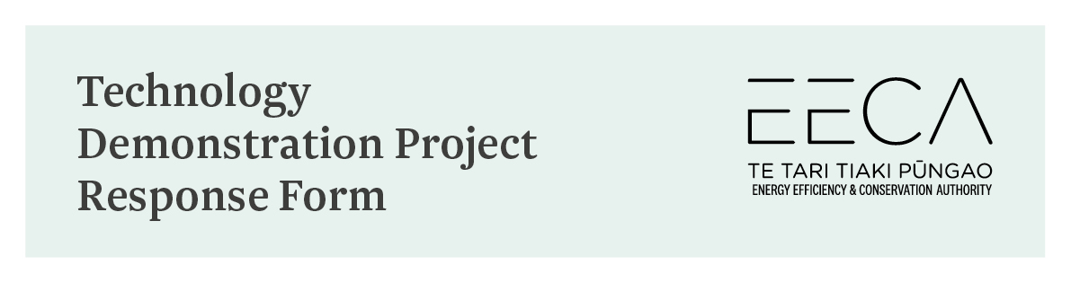
business@eeca.govt.nz

The programme is open to businesses who want to:
- install energy efficient and/or renewable energy technologies that are provided by EECA registered technology suppliers. OR
- implement an innovative energy efficiency or renewable energy process improvement opportunity themselves.
If accepted, we will fund pay up to 40% of the project costs:
- Up to $100,000 for non-process heat projects
- Up to $250,000 for projects process heat projects.
To qualify for funding, your project must:
- Reduce energy intensity or greenhouse gas emissions
- Be applicable to multiple businesses in a sector
- Be financially viable, with a reasonable payback period.
In addition, you must meet the following requirements:
- For technology related projects the technology must be commercially available and the technology supplier must first be registered with EECA
- For innovative processes projects, any process change must be proven
- You will commit to having your project independently monitored and to promoting the project and outcomes.
Projects must meet minimum cost-effectiveness requirements for energy benefits and carbon reductions. We will not consider projects that have already started or would happen anyway. We will not fund projects involving the following:
- Heat pumps < 10 kW
- residential products
- standard commercial lighting, including LED's and office products
- solar hot water and photovoltaic panels
- electric light passenger vehicles (specialist electric vehicles may be considered)
- wind, hydro and marine electricity generation
- products under research and development.
PROJECT DETAILS
All applicants must be legal entities registered in New Zealand
Name of organisation or company
Description of the project - technology or process
Short description of the project and its potential demonstration value
Status of technology
Details showing the project would use proven, commercial available technology / process improvement that is underutilised in NZ
EECA registered supplier
If applicable
Total project cost
Have costs been approved by the business? What is the timeline for this?
Incremental project cost
Cost over the cost of standard technology
EECA funding
Timeline from start to completion

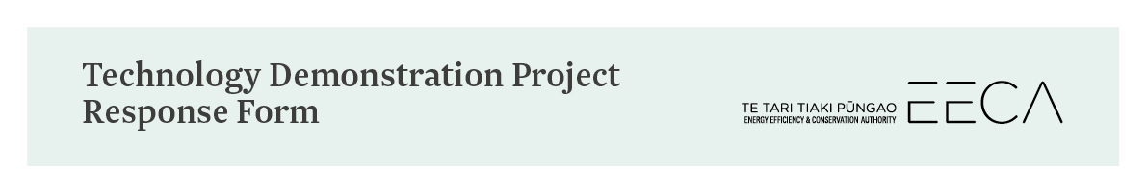
PROJECT ASSESSMENT INFORMATION
Annual energy savings
Annual CO2 reductions
Replication potential
Describe any known previous deployment history of the project, the technology and/or process in New Zealand. Provide any information you have on how many other businesses/sites in New Zealand could utilise this technology or already are; include estimated energy savings or carbon reductions if possible.
Other benefits
e.g. maintenance cost savings
Payback period
Technical ability to undertake the demonstration project

Project monitoring
Describe how the success of the project can be monitored and reported. Include what information needs to be collected to make a good case study and any expectations you have of EECA.
Describe how you plan to promote, inform, and make the benefits of the project/technology known.
Risk management
List potential risks identified, their probability of eventuating, and how you propose to mitigate or minimise them. Declare any possible conflicts of interest. Provide details of any feasibility studies undertaken in relation to the project.

APPLICANT DETAILS
Applicants must be legal entities registered in New Zealand
NZ Business number (NZBN)
NZ Physical address
Postal address
Energy use of organisation by fuel type
$ and kWh
Primary contact name and position
Phone
Email
Technology supplier contact name and position (if applicable)
Phone
Email
CONFIRMATION
By signing below you are confirming that, to the best of your knowledge, all the information provided in this application is accurate
Name
Signature
Date

