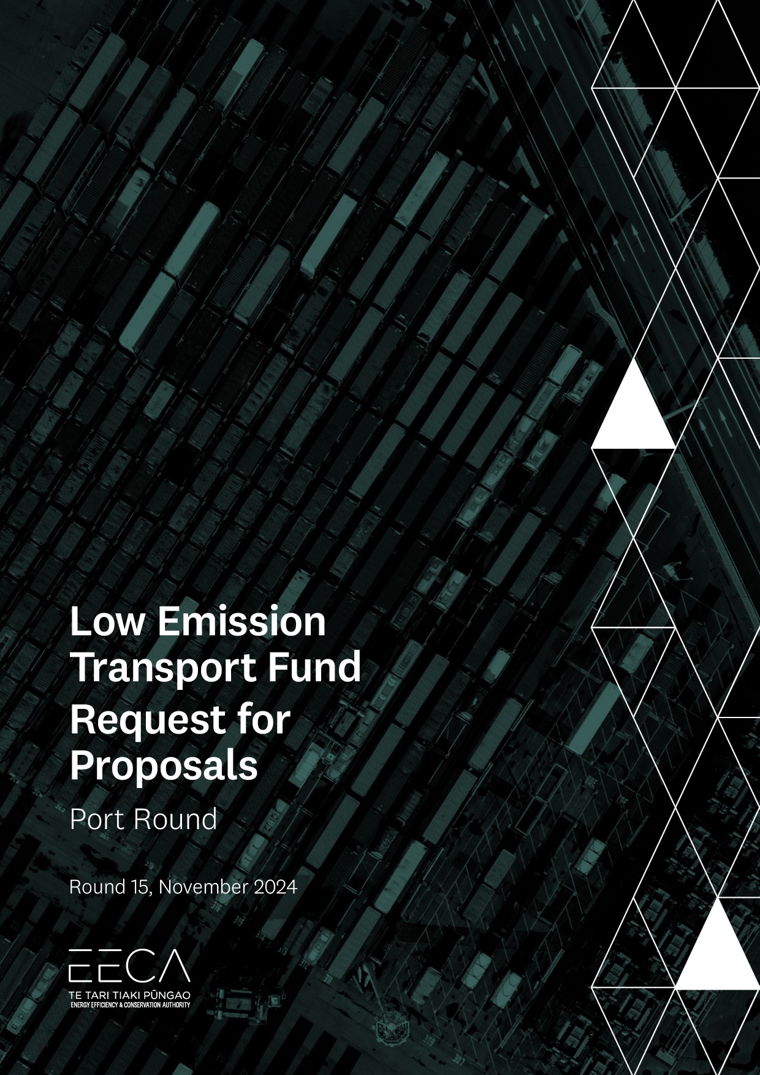

Response form: LET – Ports (Round 15)

This Request for Proposal will utilise an online form on the EECA website. This document is provided to support your response process and cannot be used to submit an application.

Welcome to the Low Emission Transport Fund – Port Round RFP (Round 15) Response Form.
Before you begin, please familiarise yourself with the following.

Key dates
RFP released: 18 November 2024.
Deadline for Questions: 12pm, 5 February 2025 (submit questions to applications@eeca.govt.nz).
Deadline for Proposals: 12pm, 10 February 2025.
Decisions are expected from April 2024.
The Proposal Validity Period is 6 months from the deadline date.

Key actions
Read the RFP document and any supporting information to ensure you have understood:
the Investment Principles
our Funding and Eligibility Conditions
our Evaluation, Assessment and Decision-Making Approach; and,
the Criteria against which Applications will be assessed.
2. Periodically check the Government Electronic Tender Service (GETS: GETS RFx IFD 30655301) and the EECA website for updates relating to this RFP.
3. Fill in this online form. You may upload supporting information such as summaries of past projects and letters of support, etc.
Applicants who save their progress in this form and have entered an email in the 'key contact’ area will receive updates at that address.

Tips for using this form:
Save as you go. You can save this form and come back to it later using the 'Save' button in the bottom right-hand corner of the page. You will be provided with a unique link that will link you back to your progress on this form. You can share this link with your teammates if they also require access. The form saves your progress every time you move between pages by clicking 'Next' or 'Back', or when you click 'Save'.
Edit the form one at a time. If there are multiple people making edits to your application, you risk overwriting each other's data. It's recommended that one person access your application form at a time to mitigate the risk of data loss. This also applies to having the form open in multiple tabs on the same device. EECA accepts no responsibility for loss of data due to overwriting.
If you accidentally close this response form browser tab, pushing Ctrl-Shift-T will reopen it. If you accidentally navigate to a new page, click the browser’s ‘back’ button.
Explore the form. Jump between sections to familiarise yourself with what is required before starting your application.
You cannot make changes to a submitted form. Make sure you have entered all the information you wish to before you press ‘submit’. Talk to us if you have concerns about what you have submitted.
Your application must be made via the online form. EECA will not accept applications received by email, post, or hand delivery, or from any party not expressly invited by EECA to apply.
If you need assistance with completing the form, or have questions about your application, contact applications@eeca.govt.nz.

Section 1 Applicant

Lead Applicant key details
Legal name
Trading as (if different)
Type of organisation | Limited liability company / Incorporated society / Trust / Charitable Trust / Incorporated Society / Other (please specify)
NZ Company Number (if a company), NZBN or Charitable Trust/Incorp Soc number
Street address
[Address, city/town, postcode]
Brief organisational overview
[maximum of 50 words]

Contact person details
This will be the only person who receives all the correspondence relating to the Registration. Fill out all fields unless otherwise indicated
Name
[Title, first and last name]
Job title or role
[E.g. Director, Manager, etc.]
Contact phone number
Contact email address
Co-Respondent key details
Use the copy and paste function to add additional Co-Respondents if required
Legal name
Trading as (if different)
Type of organisation | Limited liability company / Incorporated society / Trust / Charitable Trust / Incorporated Society / Other (please specify)
NZ Company Number (if a company), NZBN or Charitable Trust/Incorp Soc number
Key personnel
Provide contact details, role descriptions and brief profiles for each of the key personnel who will materially influence any subsequent projects.
Name:
Organisation:
Contact details:
Role:
Qualifications or relevant experience:
[Repeat for additional]
Partner organisations
Provide brief profiles for each of the key partner organisations who would be involved in delivering projects under the subsequent RFP.
[Repeat for additional]

Section 2 Minimum Eligibility Conditions
Note: Any Registrations that do not meet all the minimum eligibility conditions will not be progressed to a full assessment.
For eligibility conditions, refer to the RFP document.
Eligible entity and project
Is the lead organisation associated with this project an eligible entity?  [Refer to the RFP document to learn which entities are eligible for funding. If your lead organisation is not a NZ-based entity, you are not eligible] | - Yes ☐ No
Can the Applicant deliver projects in New Zealand?  [Projects that would be delivered in another country are not eligible to receive LETF funding. The Project may utilise overseas suppliers, but the resulting asset and decarbonisation outcomes must be New Zealand based.] | - Yes ☐ No
Does the project involve eligible technologies or activities?  [Refer to the RFP document to learn about eligible and ineligible technologies, vehicles and activities] | - Yes ☐ No
Health, safety, reputation
Are you committed to working safely, and ensuring the health and safety of workers and others affected by the proposed project work, and do you have appropriate systems and processes to undertake the work safely? | - Yes ☐ No
If your registration is successful, do you agree to provide EECA with more detail relating to your health and safety policies, plans and procedures if required? | - Yes ☐ No
Are you committed to working in a manner that will not damage EECA’s reputation? | - Yes ☐ No
Identified co-investment of at least 50%
Do you (and your co-applicants, if applicable) have the ability to co-invest at least 50% of the estimated total project cost (excl. GST)? |  | ☐ Yes ☐ No
Identify the source of your co-investment (including amounts if multiple sources)
[If there is funding which is not yet fully committed to the project, state this, and identify what conditions must be met (e.g. board approval, bank loan approval) for funding to be fully committed]
Are you (and your co-applicants, if applicable) requesting co-funding of more than 50% of total project costs? |  | ☐ Yes ☐ No  [If yes, please provide details below]
Please provide justification for why your funding request is for more than 50% of total project costs
[Funding requests exceeding 50% will only be considered in exceptional circumstances, as identified in Section 1.6 of the RFP document]
Will the project result in any new assets (either tangible or intangible)? |  | ☐ Yes ☐ No  [If yes, please provide details below]
Please provide details of all asset(s) created, their location(s) and who will own each asset at the conclusion of the project
Asset | Location | Owner
Describe how any change of asset ownership will impact the Successful Applicant (Recipient in Agreement) in terms of the insurance, asset availability and maintenance requirements in Schedule 2 of the Proposed Funding Agreement
Project size
The project funding request is at or below $500,000 (excl. GST).  [Funding requests exceeding $500,000 will only be considered in exceptional circumstances, as identified in Section 1.6 of the RFP document] |  | ☐ Yes ☐ No  [If no, please provide reasoning below]
Please provide justification for why your funding request is for an amount exceeding $500,000
Other central government funding
Have you received any other central government funding for the proposed project?  [Total central government funding, including LETF funding, cannot exceed 50% of estimated total cost of project] |  | ☐ Yes ☐ No
If yes, please identify the amount of other government funding, and the source  [All amounts should be in $NZD and exclude GST] |  | $
Have you applied for, or do you have an agreement for funding from central government for parts of, or all of, the proposed project? |  | ☐ Yes ☐ No
If yes, please identify the amount of funding, the source and stage of application process you are at  [All amounts should be in $NZD and exclude GST] |  | $

Section 3 Proposal
Please enter answers in the right-hand column. Make sure the costs in this table match your calculations in Section 5 of this document.
Proposal key details
Title
[A short title for your project, no more than 10 words]
Brief summary of your project
[Maximum of 40 words. This may be used in media releases or other external communications]
Project key success factors
[Maximum of 50 words. Describe what success looks like for this project.
In addition, list the factors that, if met, will make your project a success. These may be key performance indicators, proven benefits, or other critical success factors]
Estimated total cost of project (excl. GST)
[Do not include in-kind contributions, existing expenses such as current staff, or costs already incurred]
Total amount of co-funding to be provided by you, any co-applicants and others (excl. GST)
[Must be at least 50% of estimated total cost of project – cannot include in-kind contributions, existing expenses such as current staff, or costs already incurred]
Amount of LETF funding sought (excl. GST)
[This is the difference between the two figures above. This cannot be more than 50% of the estimated total cost of project, unless the project meets the conditions in Section 1.6 of the RFP document]
Cost of traditional / internal combustion engine (ICE) equivalent if applicable (excl. GST)
[If applicable, state the cost of an internal combustion engine (ICE) vehicle / equivalent.
Note: co-funding will only be considered for a proportion of the incremental cost (the difference between an ICE vehicle / equivalent and your project)]
What is your estimate of the potential for emissions reduction of this project? Provide a breakdown of your estimate (if applicable).

Proposal summary
Provide a summary of the project
[Maximum of 200 words]
Outline what specifically you would apply LETF funding towards (e.g. vehicles, charging infrastructure, ancillary equipment, project personnel costs etc.)
[Maximum of 200 words]

Section 4 Assessment Criteria
The following sections include details of the assessment criteria that will be used by the Assessment Panel when assessing Proposals for the LETF.
Your Proposal will be scored against your answers to these criteria. Aim to give answers that are relevant, concise and comprehensive.
If you have made any assumptions about the delivery of the project, clearly state these assumptions.
EECA’s intention is to gain sufficient information from each Applicant to fully inform the assessment and decision-making process. Please attach any further information or supporting documentation that will support or verify any statements made in response to these questions.
Please adhere to maximum word count per question.
A. Fit with the Investment Activity | Weighting 20%
- How does your Project fit the Investment Activity for this round?
- Describe your Project for this RFP.
- Describe what this Project will test that could assist others to replicate this Project.
- What key components or aspects do you consider vital for the success of the Project? Why are the costs appropriate, what other options were considered, what trade-offs have you considered?

B. Fit with Investment Principles | Weighting 40%
- Does your Project meet the Investment Principles for this Round?
- Consider the additional questions listed in the RFP.

C. Ability to Deliver | Weighting 20%
- To what extent do you have the expertise, resources, relationships and commitment necessary to deliver the initiative?
- What is your track record of delivering comparable Projects?
- EECA will work to ensure that the fund is only used to enable projects, and not subsidise projects that would happen without funding. Can you confirm your Project would not proceed without co-funding? Otherwise, explain how co-funding would accelerate the timeframe of the Project.
- Have you identified Project risks and barriers to success and how they will be addressed? e.g. supply of vehicles and components.
- How quickly can the Project be delivered?
- Have you sought confirmation and/or approvals from all relevant parties to the Project, e.g. landowners, Councils?
- Detail key staff and Project partners and their roles/contributions to the Project.
D. Value for Money | Weighting 20%
- How will the Project lead to public benefits and how large are those benefits expected to be compared to the funding being sought?
- EECA will work to ensure that the fund is only used to enable projects, and not subsidise projects that would happen without funding. Can you confirm your Project would not proceed without co-funding? Otherwise, explain how co-funding would accelerate the timeframe of the Project.
- How important is the Fund to supporting the delivery, scale, or speed with which these public benefits will be realised? What can still be achieved without funding?
- Will the Project run over multiple years or within a shorter period? When will the Project deliver the benefits promised in the Proposal?
- Broader Outcomes: Tell us about the additional social, economic, cultural or other benefits that the project will deliver

Section 5 Project Components and Declaration
For the Panel to assess your Proposal, it needs to understand the different components of the Project, their cost, and how performance and delivery would be measured. The milestones you provide here may be used to help inform the milestones in any Funding Agreement with EECA.
Major milestones of project
This table must be completed.
Please use the ‘insert row’ function if you wish to add more milestones. Ensure the totals match Section 3.
 | Project Milestone  [High-level description of key project components. Refer to RFP document] | Estimated start date | Estimated end date | Total cost to deliver this milestone (excl. GST) |  | Expected LETF funding  [Cannot be more than 50% of the individual milestone] |  | Your co-funding  [Must be at least 50% of the individual milestone] |  | Cost of ICE equivalent (if applicable)
1
2
3
4
5
TOTALS (Must equal the equivalent project costs detailed in Section 3)

Proposed Funding Agreement
Together with the RFP document we have provided you with a Proposed Funding Agreement. We need to know whether you are prepared to accept the Terms and Conditions set out in the Proposed Funding Agreement.
Please note that EECA can make Clause 10.6 of the Proposed Funding Agreement reciprocal for government agencies and insert a reference to the Local Government Official Information and Meetings Act 1987 for local government agencies.
If you have completed the Asset Ownership table in Section 2 of this form, please ensure you check the insurance, asset availability and maintenance requirements in Schedule 2 of the Proposed Funding Agreement and make any suggestions that are necessary.
Please indicate below your acceptance of the Proposed Funding Agreement.
Either:
☐ | Having read and understood the Proposed Funding Agreement for this round on the EECA website, I confirm that the terms and conditions within the agreement are acceptable. If successful, I agree to sign the Proposed Funding Agreement.
Or:
If there are any clauses that you wish to amend in the Proposed Funding Agreement this is where you note any suggestions or changes you wish to propose, referencing the appropriate clause number.
☐ | Having read and understood the Proposed Funding Agreement for this round on the EECA website, I have the following suggestions to make. If successful, I agree to sign a Funding Agreement based on the Proposed Funding Agreement subject to negotiating the following clauses:
It is important that, if asked, you can explain why your changes are important to you.
Clause | Concern | Proposed solution
[insert number] | [briefly describe your concern about this clause] | [describe your suggested alternative wording for the clause or your solution]
[insert number] | [briefly describe your concern about this clause] | [describe your suggested alternative wording for the clause or your solution]
Please use the ‘insert row’ function if you wish to add more clauses.

Declaration
I declare on behalf of the Applicant, including any Co-applicants:

Please check
☐ | that I have read this form and the RFP document and I fully understand the procedures, terms, conditions and criteria.
☐ | that this Response Form (Proposal) and the RFP document together outline the basis on which this Proposal is made and the procedures, terms, conditions and criteria for the Low Emission Transport Fund.
☐ | that the statements in this Proposal are true and the information provided is complete and correct and there have been no misleading statements or omission of any relevant facts nor any misrepresentations made.
☐ | that all named key personnel have agreed to be included in this proposal.
☐ | that EECA and its advisers may disclose to or obtain from any government department or agency, private person or organisation, any information about the Applicant or project (except that marked as “Confidential”) for the purposes of gaining or providing information related to the processing and assessment of this application.
☐ | that the Applicant will, if requested by EECA or its advisers in connection with this funding process, provide any additional information sought and provide access to its records and suitable personnel.
☐ | that if successful, I consent to the public release, including publishing on the internet, of the name of the Applicant, the amount of grant sought, the amount of funding offered, contact details of the Applicant and a description of the activity/project, and undertake to cooperate with EECA on communications relating to this Proposal, which may be in the form of a media release, case study, web content, conference presentation or whitepaper, sharing via social media, or other form as agreed with EECA.
☐ | that I understand EECA’s obligations under the Official Information Act 1982 and that, notwithstanding any relationship of confidence created as a result of this Proposal, the provisions of this Act apply to all of the information provided in this Proposal.
☐ | that all activities in the proposed project are lawful activities that will be carried out lawfully.
☐ | the Applicant is not in receivership or liquidation nor will the project be managed by someone who is undischarged as bankrupt or prohibited from managing a business.
☐ | where external providers are being employed as part of the project/activity, the relevant providers are not employees or directors of the Applicant, and nor do they have any other direct or indirect interest in the Applicant, whether financial or personal unless specifically stated in the Proposal.
☐ | that EECA has sole discretion to determine which Proposals (if any) will receive LETF investment and that I understand that there is no agreement for EECA to provide funding until both parties have signed a Funding Agreement.
☐ | that all necessary internal approvals (CEO, Board etc) and relevant budgets for the project to proceed, subject to successful LETF application, will be in place within a month of the round closure date.
☐ | that I have flagged changes to the contract that I would like to discuss with EECA.
☐ | that the amounts specified as the total project cost, my co-funding, the LETF funding sought and the incremental cost identified in Section 3 equal the corresponding totals specified in Section 5 above
☐ | that I have considered any possibility for real or perceived conflict of interest as defined in Section 7.14 of the RFP document and confirm that:  ☐ I have no real or perceived conflict of interest  OR  ☐ I may have a real or perceived conflict of interest as detailed below:  Insert details here…
☐ | that I am authorised to make this Proposal on behalf of the Applicant (including any Co-applicant) identified in Section 1 of this form.

Signature
This declaration must be signed by a person with the legal and financial authority to commit your organisation to a transaction.
Print name  TITLE  ORGANISATION |  | Signature
 |  | Date

