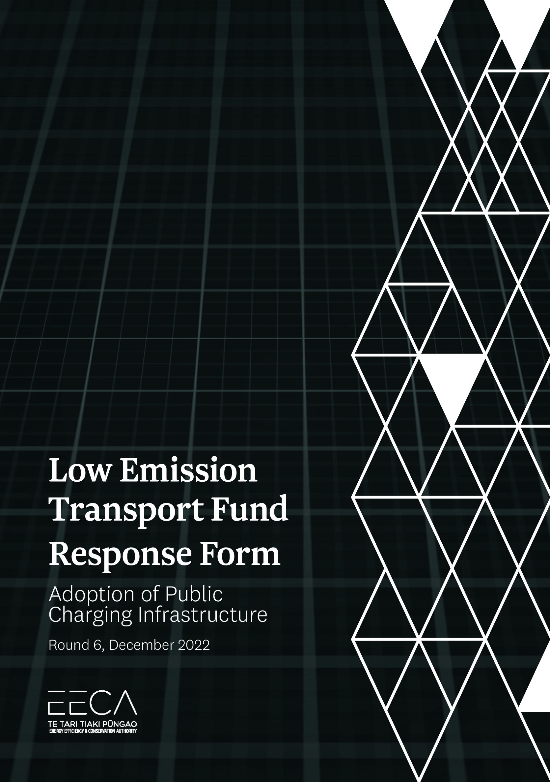

Low Emission Transport Fund – Response Form for Request for Proposal Public Charging Infrastructure (Round 6)

This Request for Proposal will utilise an online form, found on the EECA website. This document is provided to support your response process, and cannot be used to submit a Registration.
If you need any assistance with completing the form, or if you have questions about your application, please contact the LETF point of contact LETFund@eeca.govt.nz.

Key Dates
- RFP released: Thursday 1 December 2022.
- Deadline for Questions: 4pm, Wednesday 1 February 2023. (Submit questions to LETFund@eeca.govt.nz).
- Deadline for Proposals: 12pm, Wednesday 8 February 2023.
- The Proposal Validity Period is six months from the deadline date.

Key Actions
- Read the RFP document and any supporting information to ensure you have understood:
  - the Investment Principles;
  - our Funding and Eligibility Conditions;
  - our Evaluation, Assessment and Decision-Making Approach; and,
  - the Criteria against which Applications will be assessed.
- Periodically check the EECA website for any updates relating to this RFP.
- Fill in this online form. You may upload supporting information such as summaries of past projects and letters of support.
Note: Applicants who save their progress in the online Response Form and have entered an email in the Key Contact area will receive updates at that address.

Your application must be made via this online form. EECA will not accept Response Forms received by email, post or hand delivery.

Section 1 Applicant

Lead Applicant key details
Legal name
Trading as (if different)
Type of organisation | Limited liability company / Incorporated society / Trust / Charitable Trust / Incorporated Society / Other (please specify)
NZ Company Number (if a company), NZBN or Charitable Trust/Incorp Soc number
Street address
[Address, city/town, postcode]
Brief organisational overview
[maximum of 50 words]

Contact person details
This will be the only person who receives all the correspondence relating to the Registration. Fill out all fields unless otherwise indicated
Name
[Title, First and Last name]
Job title or role
[For example, Director, Manager, etc.]
Contact phone number
Contact email address
Co-Respondent key details
Use the copy and paste function to add additional Co-Respondents if required
Legal name
Trading as (if different)
Type of organisation | Limited liability company / Incorporated society / Trust / Charitable Trust / Incorporated Society / Other (please specify)
NZ Company Number (if a company), NZBN or Charitable Trust/Incorp Soc number
Key personnel
Please provide contact details, role descriptions and brief profiles for each of the key personnel who will materially influence any subsequent projects.
Name:
Organisation:
Contact details:
Role:
Qualifications or relevant experience:
[Repeat for additional]

Section 2 Minimum Eligibility Conditions
To see the eligibility conditions please refer to Section 3 of the RFP document.

Eligible entity and project
Is the lead organisation associated with this project an eligible entity?  [Refer to the RFP document to find about which entities are eligible for funding. If your lead organisation is not a NZ-based entity, you are not eligible] | - Yes ☐ No
Can the Applicant deliver projects in New Zealand?  [Projects that would be delivered in another country are not eligible to receive LETF funding. The Project may utilise overseas suppliers, but the resulting asset and decarbonisation outcomes must be New Zealand based.] | - Yes ☐ No
Does the project involve eligible technologies or activities?  [Refer to the RFP document to find out about eligible and ineligible technologies and activities] | - Yes ☐ No
Health, safety, reputation
Are you committed to working safely, and ensuring the health and safety of workers and others affected by the proposed project work, and do you have appropriate systems and processes to undertake the work safely? | - Yes ☐ No
If your registration is successful, do you agree to provide EECA with more detail relating to your health and safety policies, plans and procedures if required? | - Yes ☐ No
Are you committed to working in a manner that will not damage EECA’s reputation? | - Yes ☐ No
Identified co-investment of at least 50 per cent
Do you (and your co-applicants, if applicable) have the ability to co-invest at least 50 per cent of the estimated total project cost (excl. GST)? |  | ☐ Yes ☐ No
Identify the source of your co-investment (including amounts if multiple sources)
[If there is funding which is not yet fully committed to the project, state this, and identify what conditions must be met (e.g. board approval, bank loan approval) for funding to be fully committed]
Are you (and your co-applicants, if applicable) requesting co-funding of more than 50% of total project costs? |  | ☐ Yes ☐ No  [If yes, please provide details below]
Please provide justification for why your funding request is for more than 50% of total project costs
[Funding requests exceeding 50% will only be considered in exceptional circumstances, as identified in Section 1.6 of the RFP document]
Will the project result in any new assets (either tangible or intangible)? |  | ☐ Yes ☐ No  [If yes, please provide details below]
Please provide details of all asset(s) created, their location(s) and who will own each asset at the conclusion of the project
Asset | Location | Owner
Describe how any change of asset ownership will impact on the Successful Applicant (Recipient in Agreement) in terms of the insurance, asset availability and maintenance requirements in Schedule 2 of the Proposed Funding Agreement
Project size
The project funding request is at or below $500,000 (excl. GST).  [Funding requests exceeding $500,000 will only be considered in exceptional circumstances, as identified in Section 1.6 of the RFP document] |  | ☐ Yes ☐ No  [If no, please provide reasoning below]
Please provide justification for why your funding request is for an amount exceeding $500,000
Other central government funding
Have you received any other central government funding for the proposed project?  [Total central government funding, including LETF funding, cannot exceed 50 per cent of estimated total cost of project] |  | ☐ Yes ☐ No
If yes, please identify the amount of other government funding, and the source  [All amounts should be in $NZD and exclude GST] |  | $
Have you applied for, or do you have an agreement for funding from central government for parts of, or all of, the proposed project? |  | ☐ Yes ☐ No
If yes, please identify the amount of funding, the source and stage of application process  [All amounts should be in $NZD and exclude GST] |  | $

Section 3 Proposal
Please enter answers in the right-hand column, and make sure the costs in this table match your calculations in Section 5 of this document.
Proposal key details
Title
[A short title for your project, of no more than 10 words]
Brief summary of your project
[Maximum of 40 words. Note this may be used in media releases or other communications]
Project key success factors
[Maximum of 50 words. Describe what success looks like for this Project.
In addition, list the factors that, if met, will count your Project a success. These may be key performance indicators, proven benefits, or other critical success factors]
Estimated total cost of project (excl. GST)
[Do not include in-kind contributions, existing expenses such as current staff, or costs already incurred]
Total amount of co-funding to be provided by you, any co-applicants and others (excl. GST)
[Must be at least 50 per cent of estimated total cost of project - cannot include in-kind contributions, existing expenses such as current staff, or costs already incurred]
Amount of LETF funding sought (excl. GST)
[This is the difference between the two figures above. This cannot be more than 50 per cent of the estimated total cost of project, unless the project meets the conditions in Section 1.6 of the RFP document]
Incremental cost (excl. GST)
[This is the difference between the business-as-usual cost of undertaking your project and the cost to purchase, create or implement a low emission solution. Refer to Section 1.7 of the RFP document for guidance.

Proposal summary
Provide a summary of the project
[Please limit answer to a maximum of 200 words]
Outline what specifically you would apply LETF funding towards (e.g. charging infrastructure, connection costs, project personnel costs etc.)
[Please limit answer to a maximum of 200 words]

Section 4 Assessment Criteria
The following sections include details of the assessment criteria that will be used by the Assessment Panel when assessing Proposals to the LETF.
Your Proposal will be scored against your answers to these criteria. Aim to give answers that are relevant, concise and comprehensive.
If you have made any assumptions about the delivery of the project, clearly state these assumptions.
EECA’s intention is to gain sufficient information from each Applicant to fully inform the assessment and decision-making process. Please attach any further information or supporting documentation that will support or verify any statements made in response to these questions.
Please observe the guidance on maximum word count for each question.
A. Your Project | Weighting 40%
Describe your project and the services involved. How does your Project fit the Investment Activity for this round?
- Describe your Project for this RFP, including how the project might be staged if relevant (and the user experience and costs at each stage).
- Describe what this Project will test that could assist in designing future charging projects.
- What key components or aspects do you consider vital for the success of the Project? Why are the costs appropriate, what other options were considered, what trade-offs have you considered?
- How will your Project fit within the community in terms of amenities; will the Project overlap or support existing services?
- What is your suggested approach to branding? Note the requirement for EECA’s EV logo to be affixed to charging infrastructure as a minimum.
- Detail Project partners and their roles/contributions to the Project.

B. Ability of the Project to meet the needs | Weighting 30%
Power availability and use – Confirm site power requirements and power management plans, both initially and as stages are developed; how will the project impact network capacity, and possible impacts on other local users; how might this be managed?
Charging operation - Please describe how the site will be monitored for operational parameters such as queuing (if charging already exist, provide usage data).
User experience – Describe how the Project will deliver on accessibility, safety, utility and user experience (for example services available onsite).
Interoperability – Describe your billing system and how it will offer interoperability and seamless user experience. If your proposed solution for the prototype sites will not initially deliver this, detail your plan to meet the requirement in future.
Commercial viability – Describe how the project will inform pathways for commercial viability and scalability.
What is the magnitude of Public Benefits that the project will generate? If possible quantify the size of those benefits and estimate when they will occur. The public benefits should be closely connected to the objectives of the LETF.

C. Ability to implement | Weighting 30%
What is your track record on similar Projects?
What are the risks and barriers to success?
Speed of delivery - How quickly can the Project be delivered? Tie this to your staging plan if you have one.
Project dependencies - what interdependencies are you relying on to successfully complete the pilot?
Project plan and risk - What are the Project management strategies and mitigations to be deployed to ensure the Project remains on track and potential delays are mitigated? (specific to the Project).
Please upload a high level project plan showing acceptable milestones and realistic timelines that will see the Project delivered within the contracted period (Note: EECA accepts the plan may require adjustment when the Project is contracted).
When will the project be delivered?
Legal, property and regulatory due diligence - what is your Project’s readiness to deliver? (e.g. site scoping, regulatory and other approvals in place, supplier quotes and timelines, Applicant co-funding committed and approved, clarity about ownership of assets).
How important is the LETF support to the delivery, scale, or speed of implementation of the proposed project? Why can it not be fully funded privately? What could still be achieved without funding support? If your Project would go ahead even without LETF funding, it would not be eligible.

Section 5 Project Components
In order for the Panel to assess your Proposal, it needs to understand the different components of the project, their cost, and how performance and delivery would be measured. The milestones you provide here may be used to help inform the milestones in any Funding Agreement with EECA.
Major milestones of project
This table must be completed. Please use the ‘insert row’ function if you wish to add more milestones. Ensure the totals match Section 3.
 | Project component  [Provide a high-level description of key project components or deliverables including number of hours and charge out rates for all project personnel. Refer to RFP document] | Key performance indicator(s) | Estimated start date | Estimated end date | Total cost to deliver this milestone (excl. GST) | Expected LETF funding  [Cannot be more than 50 per cent of the individual milestone] | Your co-funding  [Must be at least 50 per cent of the individual milestone] | Incremental Cost  [What is the additional cost compared to equivalent business-as-usual activity? See RFP document]
1
2
3
4
5
TOTALS (Must equal the equivalent project costs detailed in Section 3)

Proposed Funding Agreement
Together with the RFP document we have provided you with a Proposed Funding Agreement. We need to know whether or not you are prepared to accept the terms and conditions set out in the Proposed Funding Agreement.
Please note that EECA can make Clause 10.6 of the Proposed Funding Agreement reciprocal for government agencies and insert a reference to the Local Government Official Information and Meetings Act 1987 for local government agencies.
If you have completed the asset ownership table in Section 2 of this form, please ensure you check the insurance, asset availability and maintenance requirements in Schedule 2 of the Proposed Funding Agreement and make any suggestions that are necessary.
Please indicate below your acceptance of the Proposed Funding Agreement.
Either:
☐ | Having read and understood the Proposed Funding Agreement for this round on the EECA website, I confirm that the terms and conditions within the agreement are acceptable. If successful, I agree to sign the Proposed Funding Agreement.
Or:
If there are any clauses that you wish to amend in the Proposed Funding Agreement this is where you tell us, and note below any suggestions or changes you wish to propose, referencing the appropriate clause number.
☐ | Having read and understood the Proposed Funding Agreement for this round on the EECA website, I have the following suggestions to make. If successful, I agree to sign a Funding Agreement based on the Proposed Funding Agreement subject to negotiating the following clauses:
It is important that, if asked, you are able to explain why your changes are important to you.
Clause | Concern | Proposed solution
[insert number] | [briefly describe your concern about this clause] | [describe your suggested alternative wording for the clause or your solution]
[insert number] | [briefly describe your concern about this clause] | [describe your suggested alternative wording for the clause or your solution]
Please use the ‘insert row’ function if you wish to add more clauses.

Declaration
I declare on behalf of the Applicant, including any Co-applicants:

Please check
☐ | that I have read this form and the RFP document and I fully understand the procedures, terms, conditions and criteria.
☐ | that this Response Form (Proposal) and the RFP document together outline the basis on which this Proposal is made and the procedures, terms, conditions and criteria for the Low Emission Transport Fund.
☐ | that the statements in this Proposal are true and the information provided is complete and correct and there have been no misleading statements or omission of any relevant facts nor any misrepresentations made.
☐ | that all named key personnel have agreed to be included in this proposal.
☐ | that EECA and its advisers may disclose to or obtain from any government department or agency, private person or organisation, any information about the Applicant or project (except that marked as “Confidential”) for the purposes of gaining or providing information related to the processing and assessment of this application.
☐ | that the Applicant will, if requested by EECA or its advisers in connection with this funding process, provide any additional information sought and provide access to its records and suitable personnel.
☐ | that if successful, I consent to the public release, including publishing on the internet, of the name of the Applicant, the amount of grant sought, the amount of funding offered, contact details of the Applicant and a description of the activity/project, and undertake to cooperate with EECA on communications relating to this Proposal, which may be in the form of a media release, case study, web content, conference presentation or whitepaper, sharing via social media, or other form as agreed with EECA.
☐ | that I understand EECA’s obligations under the Official Information Act 1982 and that, notwithstanding any relationship of confidence created as a result of this Proposal, the provisions of this Act apply to all of the information provided in this Proposal.
☐ | that all activities in the proposed project are lawful activities that will be carried out lawfully.
☐ | the Applicant is not in receivership or liquidation nor will the project be managed by someone who is undischarged as bankrupt or prohibited from managing a business.
☐ | where external providers are being employed as part of the project/activity, the relevant providers are not employees or directors of the Applicant, and nor do they have any other direct or indirect interest in the Applicant, whether financial or personal unless specifically stated in the Proposal.
☐ | that EECA has sole discretion to determine which Proposals (if any) will receive LETF investment and that I understand that there is no agreement for EECA to provide funding until both parties have signed a Funding Agreement.
☐ | that all necessary internal approvals (CEO, Board etc) and relevant budgets for the project to proceed, subject to successful LETF application, will be in place within a month of the round closure date.
☐ | that I have flagged changes to the contract that I would like to discuss with EECA.
☐ | that the amounts specified as the total project cost, my co-funding, the LETF funding sought and the incremental cost identified in Section 3 equal the corresponding totals specified in Section 5 above
☐ | that I have considered any possibility for real or perceived conflict of interest as defined in Section 7.14 of the RFP document and confirm that:  ☐ I have no real or perceived conflict of interest  OR  ☐ I may have a real or perceived conflict of interest as detailed below:  Insert details here…
☐ | that I am authorised to make this Proposal on behalf of the Applicant (including any Co-applicant) identified in Section 1 of this form.

Signature
This declaration must be signed by a person with the legal and financial authority to commit your organisation to a transaction.
Print name  TITLE  ORGANISATION |  | Signature
 |  | Date

