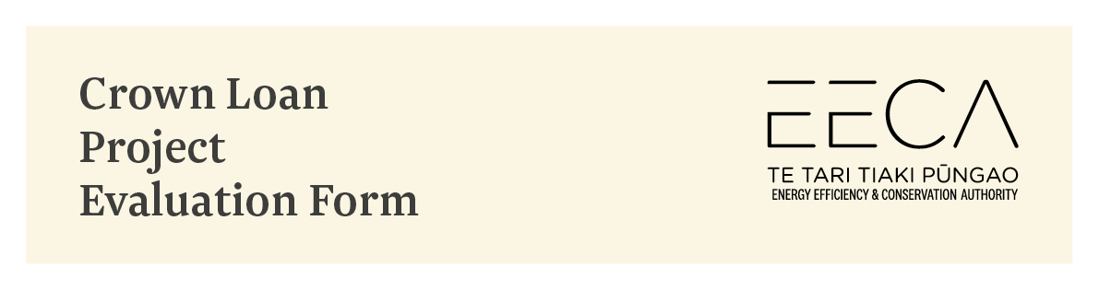
Important: This form is to be completed and submitted along with your Application form.
This Project Evaluation form is provided to assist applicants prepare their applications for Crown loan funding and ensure all applications are treated in a fair and consistent manner.
Please ensure you complete each section. All responses should be brief and factual.
Where relevant, please include additional supporting documents.
Where data in the Project Evaluation form is repeated in the Application form, it is necessary to complete both forms. Do not put “refer Project Evaluation form” or “see attached”.
Important: Remove all prompts (all blue italicised text) on completion of this Project Evaluation form.
Handwritten Project Evaluation forms will not be accepted.

- Applicant Details
Name of organisation
Name of project manager
/ contact person:
Date of application

- Description of the Project
Title of project:
Total project cost
(excl GST)
EECA loan amount
Non-EECA funding | List all other sources of funding for this project
Location of project (physical address / s)

Project description
- Provide an outline of the project, the rationale for the project and expected outcomes.
- Ensure the evaluation panel clearly understands what the project is trying to achieve.

- Energy and cost savings
Summary of savings by measure
Description | Demand reduction (kW) | Electricity savings (kWh) | Other fuel savings (kWh) | Project Cost ($) | Energy & Demand Savings ($) | Non energy savings ($) | Project Payback (Years)
e.g Lighting
e.g BMS upgrade
Total
Describe how the energy and cost savings above are going to be achieved. On completion of this section, a reviewer should:
  - know what technologies are being employed and how the savings are being achieved. It should include calculations or a spreadsheet or both.
  - have confidence the savings projections are realistic and achievable.
In order to achieve this it is necessary to specify the type of technology, quantities, hours of use and energy tariffs e.g. consider a lighting upgrade:
Type of technology Replacing twin 36 watt T8 fluorescent fittings at 90 watts / fitting (includes ballast losses) with twin T5 28 watt fittings at 62 watts / fitting to achieve reductions of 28 watts / fitting
Quantities 120 fittings
Hours of use 3,000 hours p.a.
Tariffs 18 cents / kWh

- Impact of the project on the site’s total energy use:
Fuel type | Current use p.a. (kWh) | Proposed use p.a. (kWh) | Reduction / Savings (kWh) | Current cost p.a. ($) | Proposed cost p.a. ($) | Reduction / Savings ($)
Electricity
Gas
LPG
Total

- Greenhouse gas reductions
Fuel type saved | Energy (fuel) savings | Conversion factor | CO2 reductions (tonnes)
Electricity |  | 0.0001014 tCO₂/kWh
Natural Gas |  | 0.000195 tCO₂/kWh
Diesel |  | 0.00266 tCO₂/litre
LPG |  | 0.00303 tCO₂/kg
Petrol |  | 0.00245 tCO₂/litre
Coal & Other | Refer MfE website:  Measuring Emissions Factors Summary 2020 final.pdf (mfe.govt.nz)

- Co - benefits of the Project
Project benefit | Description
(e.g. maintenance cost savings, improved working environment, productivity increases, noise reduction, health and safety etc.) | Provide details of the expected benefit of the project. Include details of any equipment that the funding will make redundant.  Provide details of payback period or IRR where applicable.

- Ability to be Replicated
If available, provide any information you have on how many other organisations in New Zealand could utilise this technology or already are using it.
How can this project be replicated or learned from for use in other situations?
What is the current market share of the technology in New Zealand?

- Likelihood project will proceed
 | Likelihood (%) | Comment
In event this application is successful, the likelihood of the project proceeding is:

- Project Timeline
Proposed project timeline (key activities / milestones):
Date | Activity / milestone
 | Loan funds received from EECA
 | Practical completion

This should be limited to about 6 key milestones including project tender and evaluation, installation start date, 2-3 key project activities or milestones, commissioning and acceptance, and the date of practical completion.
Note: the commitment of project funds (e.g. entering into contracts with service providers, ordering of equipment etc.) needs to occur after EECA advises loan funding for this project has been approved – not prior to EECA approving loan funding for this project.

- Project Auditing and Monitoring
Provide details about how you intend to report on the projects progress.
Describe how the success of the project can be measured and reported.
Consider what information needs to be collected to make a good case study for EECA to publish on its website or to share with other government organisations and businesses.
Provide details on how the project can be audited to assess product quality or durability and installation quality.

- Additional information
List any additional information attached in the following table.

1

2

3

SIGNATURE:

NAME:
POSITION:

